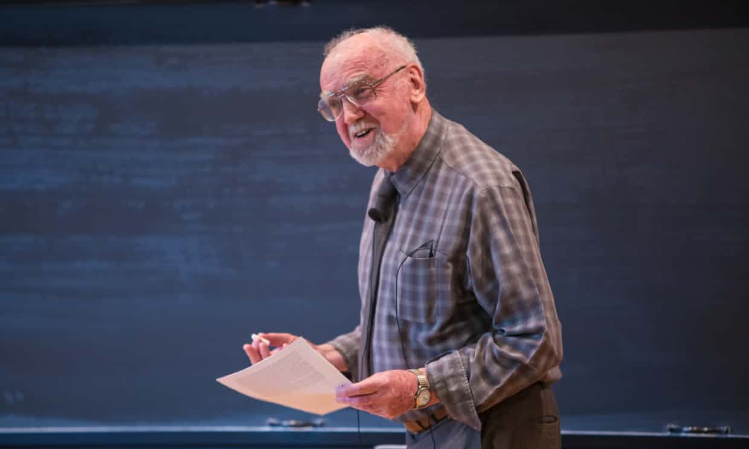
[Please add a photo .jpeg, .jpg, .png, etc format]
[Name Surname:]
[Adress: ]
[E-Mail: ………..]

Short Biography:
[Maximum 150 words]

Selected Publications:
- E. Aydiner, “Article title”, Journal name, Volume, page (Year). DOI:….
- ..
- …

Title and Short Summary of the Talk:
[Maximum 150 words]

References
[1] E. Aydiner, “Article title”, Journal name, Volume, page (Year).
[2] …..

